CYBER RISK ASSESSMENT & THREAT INTELLIGENCE
Submitted by:
Gayathri
Batch No:13
Email Id:
gayathrithalla28@gmail.com
Date:27.03.2026

Contents:
1. Introduction
2. Description
3. Objectives
4. System Architecture
5. Modules Description
6. Tools & Technologies
7. Results
8. Conclusion

INTRODUCTION:
In today’s digital world, organizations depend heavily on network systems and online services. This increasing dependence makes them vulnerable to various cyber threats such as hacking, malware, and data breaches. Identifying vulnerabilities and assessing risks has become a critical part of cybersecurity.

The Cyber Risk Assessment & Threat Intelligence system is designed to detect vulnerabilities, analyze threats, and evaluate the overall risk of a target system. It combines network scanning with threat intelligence to provide meaningful insights into security issues.

This project helps users understand potential risks in their systems and take preventive actions before any serious cyber attack occurs. It also provides visualization and reporting features to make analysis easier and more effective.

DESCRIPTION:
The Cyber Risk Assessment & Threat Intelligence project is a web-based application developed using Python and Streamlit. It allows users to enter a target such as a domain name or IP address and perform a scan to identify open ports and running services.

After scanning, the system processes the results using a threat intelligence module that evaluates potential risks associated with each service. A risk engine calculates the severity and assigns a risk score based on different factors.

The results are displayed in a dashboard that includes risk summaries, host details, and graphical charts. The system also provides an email alert feature that notifies users about high-risk vulnerabilities.

Overall, this project provides a simplified but effective way to assess cybersecurity risks and visualize threat data in an organized manner.

OBJECTIVES:
The main objectives of this project are:

• To identify vulnerabilities in a target system
• To scan open ports and detect running services
• To evaluate risk levels based on severity and threat data
• To provide threat intelligence insights for better analysis
• To visualize cybersecurity data using charts and dashboards
• To generate alerts for high-risk vulnerabilities
• To help users take preventive security measures

SYSTEM ARCHITECTURE:
The system follows a structured workflow to perform risk assessment and threat analysis.

First, the user enters a target such as a domain or IP address. The scanner module scans the target and identifies open ports and services. The collected data is then passed to the threat intelligence module, which analyzes potential threats.

Next, the risk engine calculates the risk score and assigns severity levels such as Low, Medium, High, or Critical. The results are then displayed on a dashboard with charts and tables for easy understanding.

Finally, the system can send email alerts to notify users about high-risk vulnerabilities.

Workflow:
User Input → Scanner → Threat Intelligence → Risk Engine → Dashboard → Email Alert

MODULES DESCRIPTION:
The project is divided into several modules, each responsible for a specific task.

scanner.py:
This module performs network scanning on the given target. It identifies open ports and running services.

threat_intel.py:
This module provides threat intelligence by analyzing the services and identifying potential threats.

risk_engine.py:
This module calculates the risk score and assigns severity levels based on the collected data.

alert.py:
This module is responsible for sending email alerts to notify users about high-risk vulnerabilities.

app.py:
This is the main Streamlit application that provides the user interface and displays results in the form of tables and charts.

TOOLS & TECHNOLOGIES:
The project is developed using the following tools and technologies:

• Python – Core programming language
• Streamlit – Web application framework
• Pandas – Data processing and analysis
• Matplotlib – Data visualization and charts
• NumPy – Numerical computations

RESULTS:
The system successfully scans the target and identifies open ports and services. It calculates risk scores and categorizes them into different severity levels.

The dashboard displays the following results:

• Total risk score and number of vulnerabilities
• Host details with port, service, risk, and severity
• Charts showing service distribution and risk analysis
• Email alert preview with risk details

The results help users understand which services are vulnerable and require immediate attention.
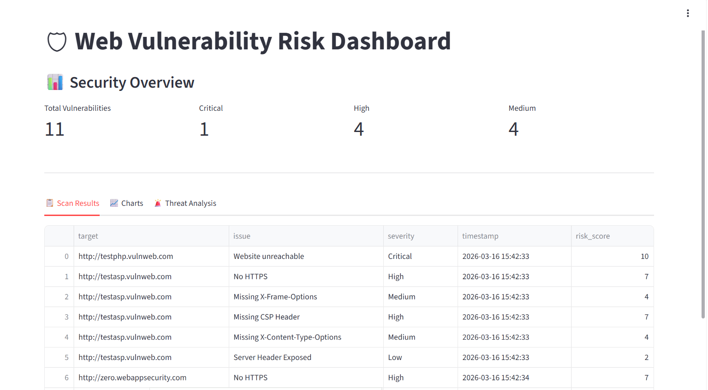
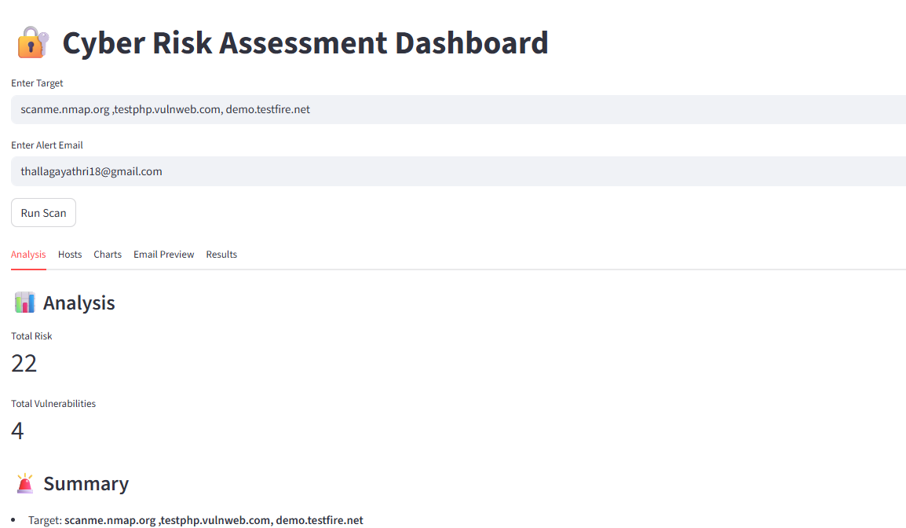

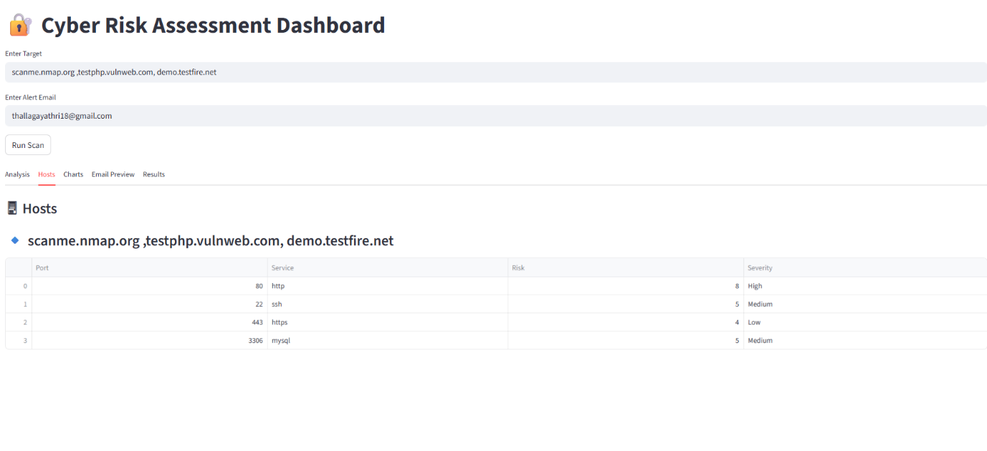

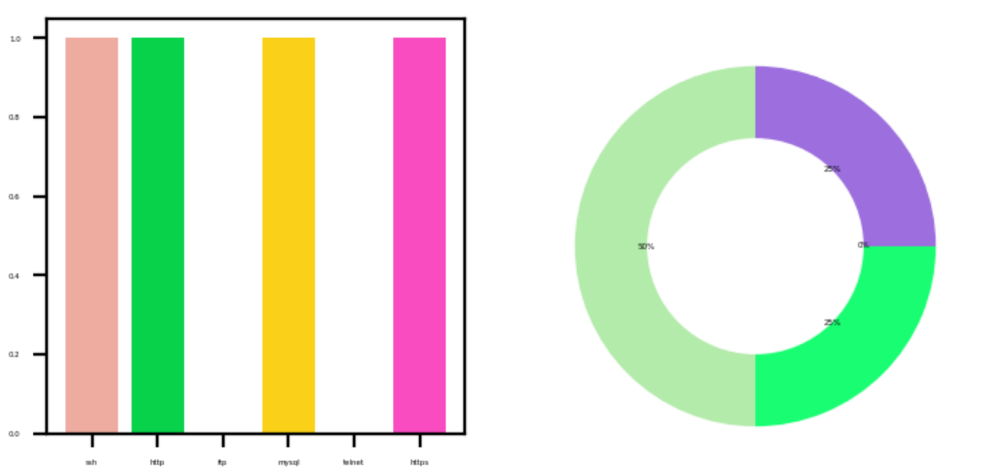

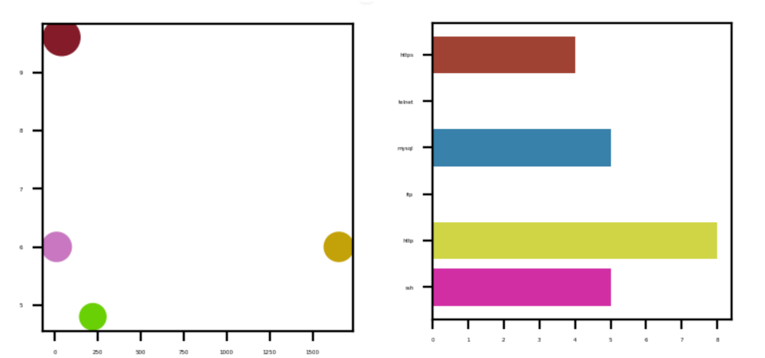

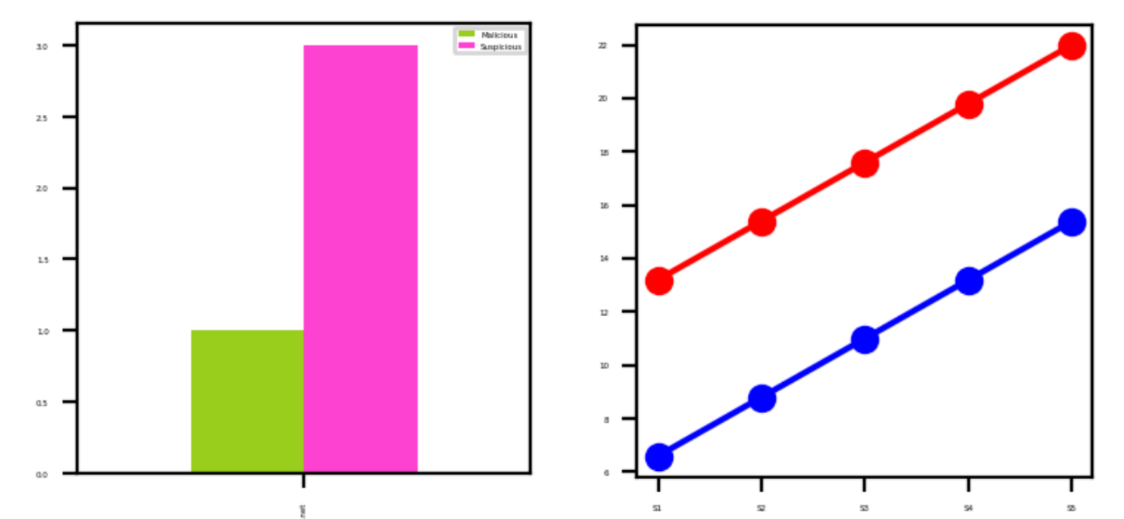

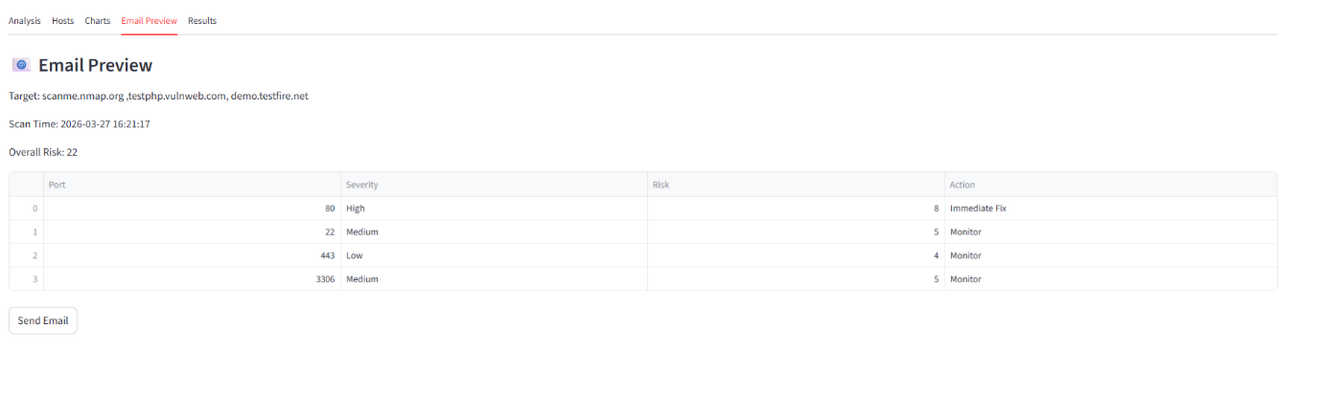

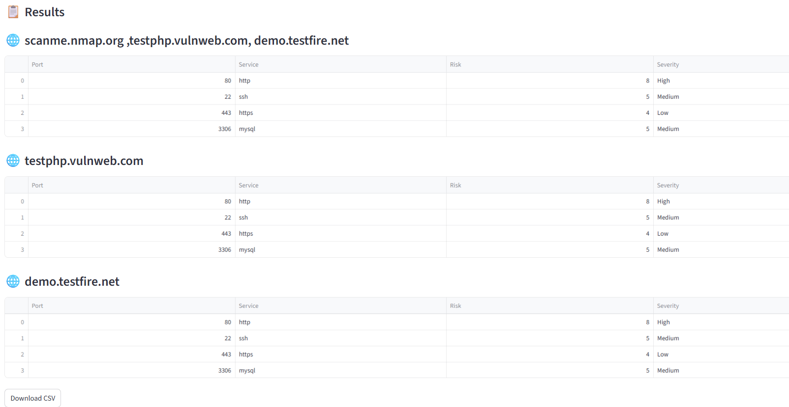
CONCLUSION:
The Cyber Risk Assessment & Threat Intelligence project provides an effective solution for identifying vulnerabilities and assessing cybersecurity risks. It combines scanning, analysis, and visualization to help users understand potential threats.

The system enables proactive security measures by highlighting high-risk services and providing actionable insights. It can be further enhanced by integrating real-time threat intelligence and advanced security features.

Overall, the project demonstrates how cybersecurity tools can help protect systems from potential attacks.

